Prismoid

Definition
# Source: AI Source: Provided by: [Data Path: Persons Table -> ID Column: 1, Name_En Column: Motasem Essam] -> From: [ChatGPT] on [7/25/2026]
A Prismoid is a three-dimensional polyhedron with two parallel polygonal bases and lateral faces that are trapezoids or triangles. The two bases may have different shapes, sizes, and numbers of sides, provided they lie in parallel planes.
A prismoid is closely related to a prismatoid. In some mathematical and engineering references, the terms are used interchangeably; in more specific classifications, prismatoid is the broader category, while prismoid refers to a solid whose lateral faces are trapezoids.
Its volume can be calculated using the prismoidal formula, which uses the areas of the two bases and the cross-section halfway between them.

Geometric Structure
# Source: AI Source: Provided by: [Data Path: Persons Table -> ID Column: 1, Name_En Column: Motasem Essam] -> From: [ChatGPT] on [7/25/2026]
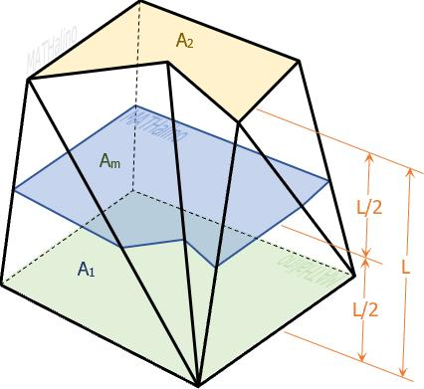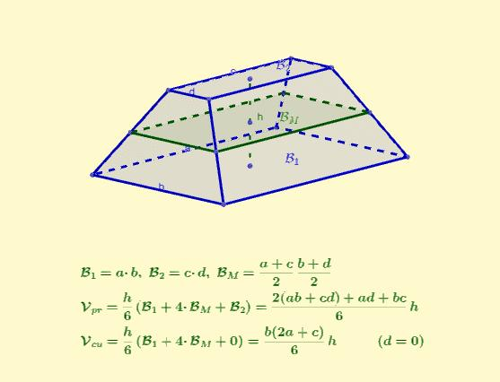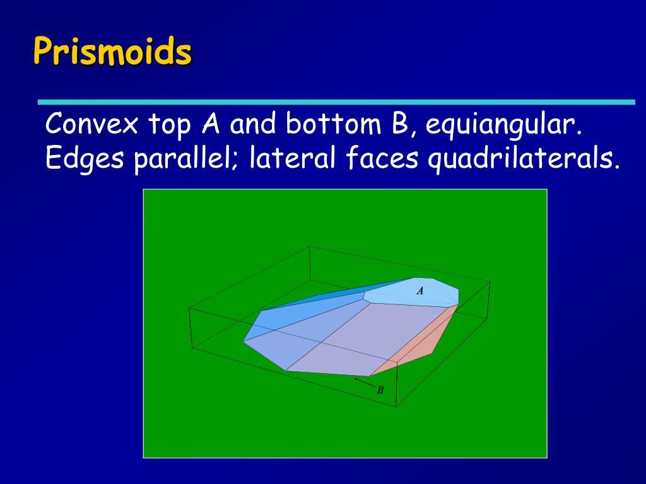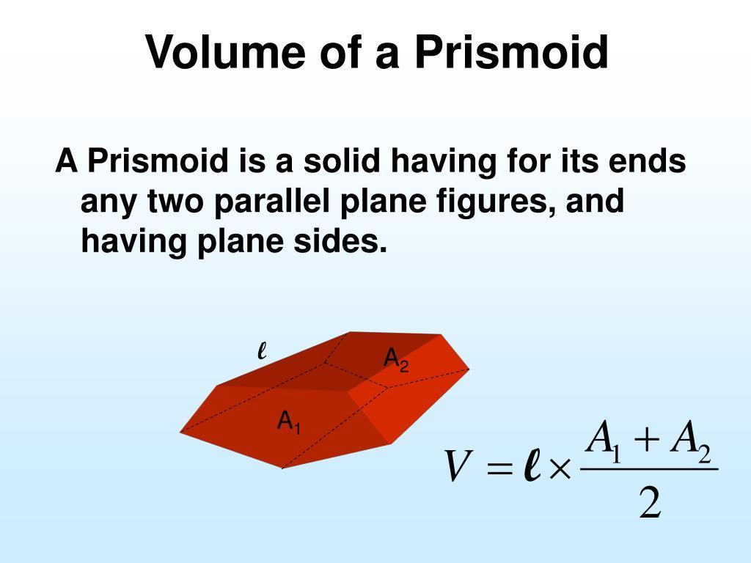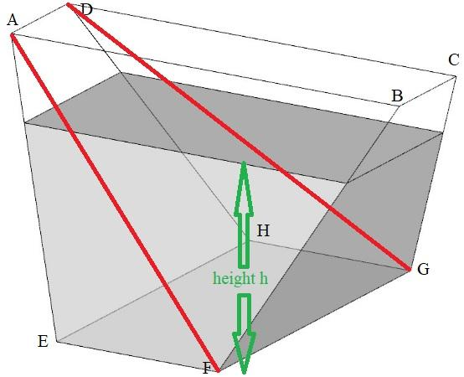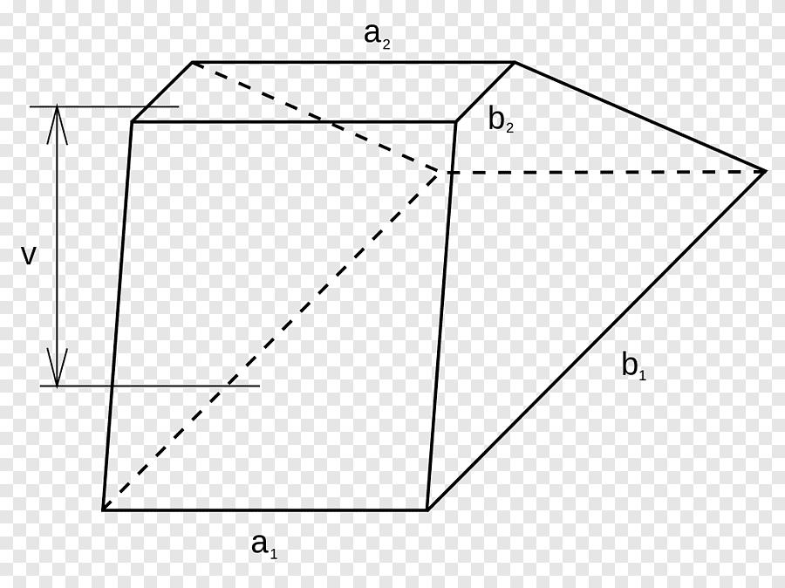
A prismoid has the following principal elements:
- Lower Base: A polygon forming one end of the solid.
- Upper Base: A polygon in a plane parallel to the lower base.
- Lateral Faces: Planar quadrilaterals, typically trapezoids or parallelograms.
- Lateral Edges: Edges connecting corresponding vertices of the two bases.
- Altitude (Height): The perpendicular distance between the two base planes.
- Midsection: The polygonal cross-section halfway between the two bases, parallel to them.

Face Composition
# Source: AI Source: Provided by: [Data Path: Persons Table -> ID Column: 1, Name_En Column: Motasem Essam] -> From: [ChatGPT] on [7/25/2026]
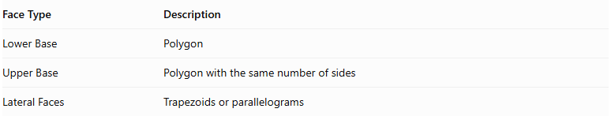
Face Type | Description
Lower Base | Polygon
Upper Base | Polygon with the same number of sides
Lateral Faces | Trapezoids or parallelograms
The number of lateral faces equals the number of sides of either base.

Mathematical Properties
# Source: AI Source: Provided by: [Data Path: Persons Table -> ID Column: 1, Name_En Column: Motasem Essam] -> From: [ChatGPT] on [7/25/2026]
A prismoid does not have one fixed number of faces, edges, or vertices because these depend on the number of sides of its bases.
For a prismoid with $n$ sides on each base:
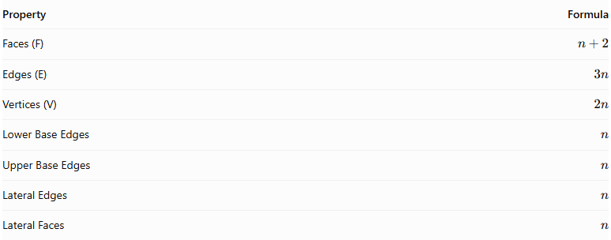
Property | Formula
Faces (F) | $$n+2$$
Edges (E) | $$3n$$
Vertices (V) | $$2n$$
Lower Base Edges | $$n$$
Upper Base Edges | $$n$$
Lateral Edges | $$n$$
Lateral Faces | $$n$$
Euler characteristic:
$$V-E+F=2n-3n+(n+2)=2$$
Prismoidal Volume Formula:
$$\boxed{V=\frac{h}{6}(A_{1}+4A_{m}+A_{2})}$$
Where:
- $V$ = Volume.
- $h$ = Perpendicular height between the bases.
- $A_{1}$ = Area of the lower base.
- $A_{2}$ = Area of the upper base.
- $A_{m}$ = Area of the midsection.
This formula calculates the volume exactly for a prismatoid, including a prismoid.

Geometric Characteristics
# Source: AI Source: Provided by: [Data Path: Persons Table -> ID Column: 1, Name_En Column: Motasem Essam] -> From: [ChatGPT] on [7/25/2026]
- Parallel Bases: The two polygonal bases lie in parallel planes.
- Equal Number of Base Vertices: Both bases have the same number of vertices.
- Quadrilateral Lateral Faces: The lateral faces are trapezoids or parallelograms.
- Variable Base Geometry: The bases do not need to be congruent or similar.
- Variable Inclination: The lateral edges may be inclined rather than perpendicular to the bases.
- Convexity: Prismoids are commonly studied as convex polyhedra, although broader definitions can include non-convex forms.

Types of Prismoids
# Source: AI Source: Provided by: [Data Path: Persons Table -> ID Column: 1, Name_En Column: Motasem Essam] -> From: [ChatGPT] on [7/25/2026]
Prismoids can be classified according to the polygonal shape of their bases:
- Triangular Prismoid
- Quadrilateral Prismoid
- Pentagonal Prismoid
- Hexagonal Prismoid
- Heptagonal Prismoid
- Octagonal Prismoid
- Nonagonal Prismoid
- Decagonal Prismoid
- N-gonal Prismoid

Related Geometric Solids
# Source: AI Source: Provided by: [Data Path: Persons Table -> ID Column: 1, Name_En Column: Motasem Essam] -> From: [ChatGPT] on [7/25/2026]
- Prism – A special case of a prismoid with congruent, parallel bases.
- Pyramidal Frustum – A prismoid with similar polygonal bases.
- Prismatoid – The broader category that includes prismoids.
- Antiprism – A related prismatoid with triangular lateral faces; it is not a prismoid under the narrower definition used here.

Main Classification
# Source: AI Source: Provided by: [Data Path: Persons Table -> ID Column: 1, Name_En Column: Motasem Essam] -> From: [ChatGPT] on [7/25/2026]
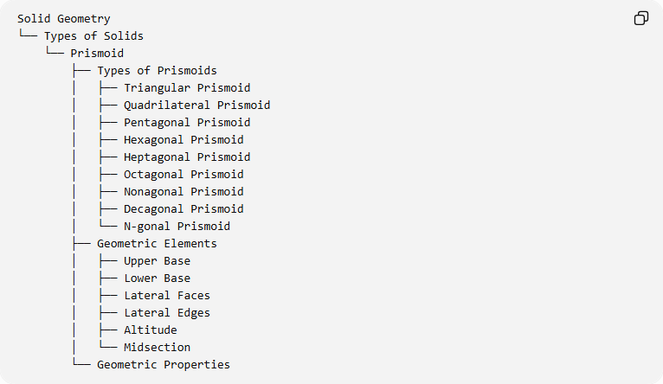
Solid Geometry
└── Types of Solids
└── Prismoid
├── Types of Prismoids
│ ├── Triangular Prismoid
│ ├── Quadrilateral Prismoid
│ ├── Pentagonal Prismoid
│ ├── Hexagonal Prismoid
│ ├── Heptagonal Prismoid
│ ├── Octagonal Prismoid
│ ├── Nonagonal Prismoid
│ ├── Decagonal Prismoid
│ └── N-gonal Prismoid
├── Geometric Elements
│ ├── Upper Base
│ ├── Lower Base
│ ├── Lateral Faces
│ ├── Lateral Edges
│ ├── Altitude
│ └── Midsection
└── Geometric Properties

Constructing a Prismoid

Geometric Instruments Used
# Source: AI Source: Provided by: [Data Path: Persons Table -> ID Column: 1, Name_En Column: Motasem Essam] -> From: [ChatGPT] on [7/25/2026]
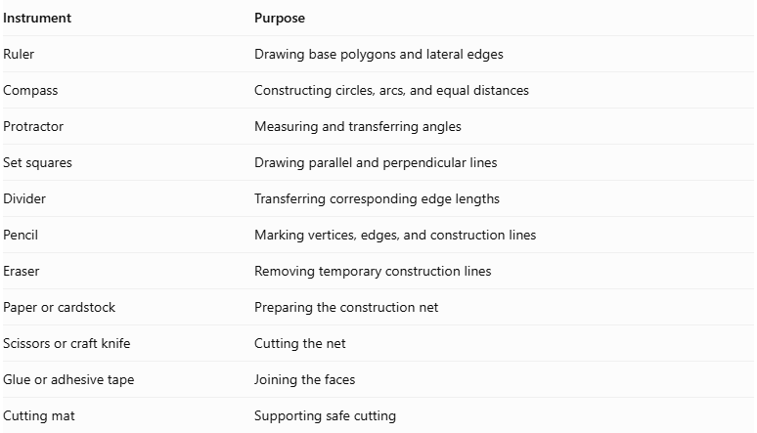
Instrument | Purpose
Ruler | Drawing base polygons and lateral edges
Compass | Constructing circles, arcs, and equal distances
Protractor | Measuring and transferring angles
Set squares | Drawing parallel and perpendicular lines
Divider | Transferring corresponding edge lengths
Pencil | Marking vertices, edges, and construction lines
Eraser | Removing temporary construction lines
Paper or cardstock | Preparing the construction net
Scissors or craft knife | Cutting the net
Glue or adhesive tape | Joining the faces
Cutting mat | Supporting safe cutting

Instrument-Based Construction Procedures

Method 1: Construction Using a Geometric Net
# Source: AI Source: Provided by: [Data Path: Persons Table -> ID Column: 1, Name_En Column: Motasem Essam] -> From: [ChatGPT] on [7/25/2026]
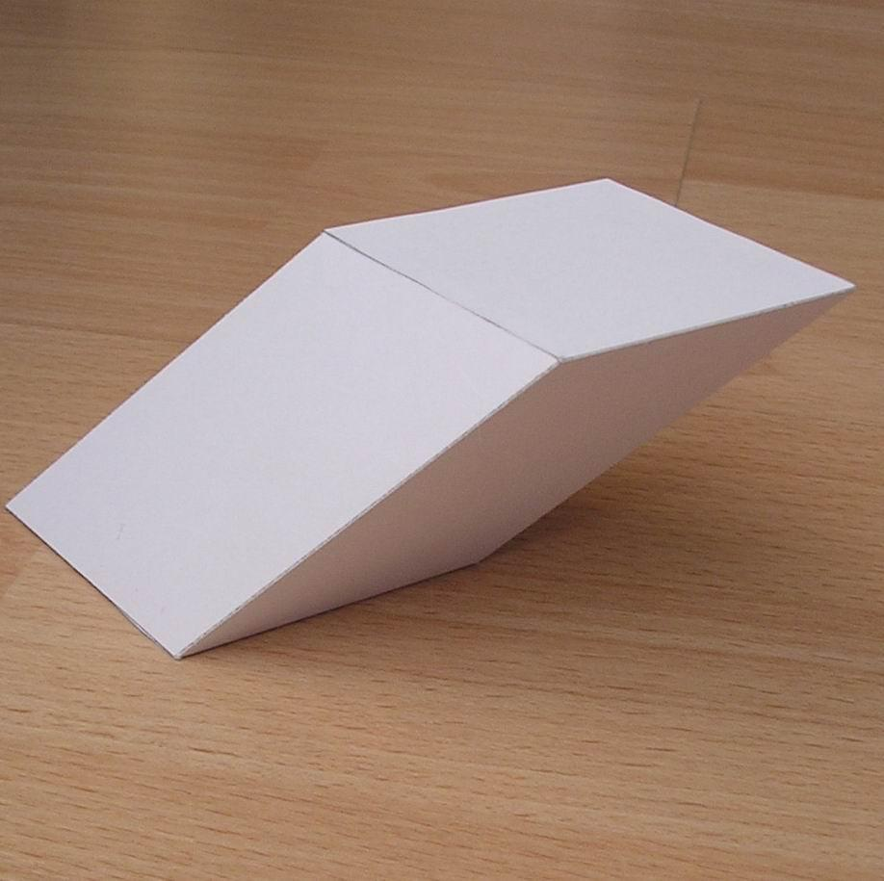
- Determine the base polygon: Choose the number of sides and dimensions for the two parallel bases.
- Construct the lower base: Use a ruler, compass, and protractor to draw the first polygon.
- Construct the upper base: Draw the second polygon with the same number of vertices, using the required dimensions.
- Determine corresponding vertices: Match each vertex of the lower base with its corresponding vertex on the upper base.
- Construct the lateral faces: Draw the required trapezoids or parallelograms between corresponding base edges.
- Arrange the net: Connect the lateral faces in their correct sequence, attaching the upper and lower bases at their appropriate edges.
- Add joining tabs: Include tabs along selected external edges.
- Cut out the net: Carefully cut around its external boundary.
- Fold the faces: Fold along the designated joining edges.
- Join the structure: Attach the lateral faces and bases using glue or adhesive tape.
- Verify the solid: Check that the bases are parallel and that all lateral faces close correctly.

Method 2: Construction Using Two Parallel Polygonal Bases
# Source: AI Source: Provided by: [Data Path: Persons Table -> ID Column: 1, Name_En Column: Motasem Essam] -> From: [ChatGPT] on [7/25/2026]
- Draw the lower base: Construct a polygon with the required number of sides.
- Establish the height: Draw a perpendicular reference line representing the distance between the two base planes.
- Construct the upper base plane: Use set squares and a ruler to establish a plane parallel to the lower base plane.
- Draw the upper polygon: Construct a polygon with the same number of vertices as the lower base.
- Determine vertex correspondence: Match the vertices of the two polygons in the intended order.
- Connect corresponding vertices: Draw the lateral edges between the two bases.
- Construct the lateral faces: Join corresponding base edges to form planar trapezoids or parallelograms.
- Check the geometry: Verify that each lateral quadrilateral is planar and that the two bases remain parallel.
- Complete the solid: Darken the visible edges and use dashed lines for hidden edges.
Important: The positions of the two polygons must be compatible with planar lateral faces. Arbitrarily choosing two polygons with the same number of vertices does not automatically produce a valid prismoid.

Method 3: Construction Through Parallel Cross-Sections
# Source: AI Source: Provided by: [Data Path: Persons Table -> ID Column: 1, Name_En Column: Motasem Essam] -> From: [ChatGPT] on [7/25/2026]
- Construct the lower base: Draw the first polygon in its own plane.
- Construct the upper base: Draw the second polygon in a parallel plane.
- Establish corresponding vertices: Identify the matching vertices and edges.
- Construct the lateral surfaces: Connect the corresponding edges using planar quadrilateral faces.
- Locate the middle plane: Mark the halfway point along the perpendicular height.
- Draw the midsection: Construct the intersection of the solid with a plane parallel to the two bases at half the height.
- Determine the three cross-sectional areas: Identify the lower-base area, upper-base area, and midsection area.
- Complete the geometric representation: Show the bases, lateral faces, midsection, and perpendicular height.
This method is particularly useful for understanding the prismoidal volume formula.

Key Points
# Source: AI Source: Provided by: [Data Path: Persons Table -> ID Column: 1, Name_En Column: Motasem Essam] -> From: [ChatGPT] on [7/25/2026]
- A prismoid is a type of prismatoid.
- Its two bases lie in parallel planes and have the same number of vertices.
- Its lateral faces are trapezoids or parallelograms.
- Its bases may differ in size and shape.
- Its volume is calculated using the prismoidal formula.
- A prism and a pyramidal frustum are special examples of prismoids.

Conclusion
# Source: AI Source: Provided by: [Data Path: Persons Table -> ID Column: 1, Name_En Column: Motasem Essam] -> From: [ChatGPT] on [7/25/2026]
The Prismoid is a family of polyhedra characterized by two parallel polygonal bases and quadrilateral lateral faces. It provides a useful geometric classification for studying prisms, pyramidal frustums, and other related solids.
Terminology note: Some mathematical references use prismoid and prismatoid interchangeably. For your taxonomy, keeping Prismoid as a narrower category under Prismatoid provides a useful distinction.

